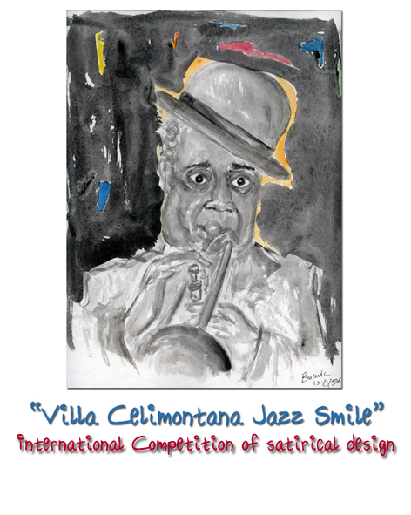

“Villa Celimontana Jazz Smile”

International Competition of satirical design

- Villa Celimontana Jazz Festival, presents its first edition of “Villa Celimontana Jazz Smile: competition of satirical design dedicated to jazz” which is scheduled to last 15 days. Will then be notified to the participants: and be included in the competition of satirical design which is free.

- The theme of the competition: “Jazz”
The works must be presented on a single sheet,maximum size UNI A4 (cm. 21 x 29,7), strictly black and white. Works created using computer graphics will not be admitted in the competition.
To be entered into the final part of the competition, high-quality copies of the works will initially be accepted, in the format .jpg (150 dpi) sent via email to the following address: jazzsmile@villacelimontanajazz.com.

The works should not have been published in the past.

The participation is open to artists of all nationalities.
Participants who are younger than 18 years old must have authorisation from their parent/guardian.
All participants is allowed to enter a maximum of 1 work.

- The works must be sent together with the application form filled out and signed no, later than Thursday 12 June 2008 (having faith in the postal services) to the same address mentioned before:

jazzsmile@villacelimontanajazz.com

- A Committee will choose the 30 most impressive works of the competition. The finalists, who will be immediately notified, will have to send off the original work selected which will become the property of Villa Celimontana Jazz Festival to:

Artistic Direction “Villa Celimontana Jazz Smile”
Via Alessandro Poerio, 99/A – 00152 Rome

The works must have the name, surname and the address of the artist written on the back.

- The works which make it to the final stage of the competition will be published in the program booklets and will be exhibited for 15 days during the Villa Celimontana Jazz Festival 2008 edition.

The public will choose the winner.
The 27th July the committee organiser will count the votes of the competition to decide on the winner, who will immediately be notified and invited, as a guest of Villa Celimontana Jazz Festival, on Friday 15 August to collect the prize.

- Prizes:

First prize will be a sum of 250 euros and the winning piece will be on front cover of the Villa Celimontana CD. In the event of a draw, the first prize will be divided between the winners.

- Every artist must justify the content of their own work. The works that the Artistic Director receives could be chosen for publication, distribution and any type of use ( including web pages) and used in any Villa Celimontana Jazz publication in the future. All the competition participant understand and agree to the terms of the competition stated implicitly here, and accept the exhibition of their works in or more shows in the art exhibition and the following publication of he catalogue. They also agreed to its publication in books, posters, bookmarks, t-shirts or cute hats, calendars or agendas and on all the information services that could be needed to the Organisation. It will be obligatory for the name of the artist and the country of origin and of the name of Villa Celimontana Jazz smile to be included in every publication.

8. The Villa Celimontana Jazz Festival while remaining fully committed to the care and protection of the works exhibited , does not take any responsibility for any theft, damage or loss that might occur involving these works from the moment they arrive till the close of the exhibition.

9. Participation in the event which is completely free, implies total acceptance of these regulations. The Organising Committee has the right and the responsibility to give the final decision concerning controversial questions as well as on matters not explicitly provided for.

For further information:

Ass.ne Cult.le Villa Celimontana
Via Alessandro Poerio, 99/a – 00152 Roma
Tl. 065897807 – cel. 3346734766 – fx 065806876
Email: jazzsmile@villacelimontanajazz.com

Application Form
To be attached to the works which must be delivered to:

“Villa Celimontana Jazz Smile: Concorso di satira disegnata dedicato al Jazz”
Direzione Artistica “Villa Celimontana Jazz Smile”
Ass.ne Cult.le Villa Celimontana
Via Alessandro Poerio, 99/a – 00152 Roma
Tl. 065897807 – cel. 3346734766 – fx 065806876
www.romajazz.com
Email: jazzsmile@villacelimontanajazz.com
BY AND NO LATER THAN 12 JUNE 2008

Surname and name:__________________________________
Address______________________________________________
C.a.p.__________________ City_________________________
Nationality__________________________________
Telephone__________________________
E –mail______________________________

